# AI Tools Assignment – Part 1: Theoretical Understanding

Prepared by: Nolly Masai

## Q1: Explain the primary differences between TensorFlow and PyTorch. When would you choose one over the other?

TensorFlow and PyTorch are two leading deep learning frameworks used to design and train neural networks. They differ mainly in computation graphs, ease of use, and deployment readiness.

|  |  |  |
| --- | --- | --- |
| Feature | TensorFlow | PyTorch |
| Computation Graph | Static (pre-defined) – optimized for production | Dynamic (on-the-fly) – intuitive for research |
| Ease of Use | Complex but scalable with TensorBoard & Serving | Simple and pythonic; easy debugging |
| Deployment | Excellent for production (mobile/web) | Great for research and experiments |
| Visualization | TensorBoard for visual tracking | Requires external libraries (Matplotlib) |

Choose TensorFlow for enterprise-level and production-ready applications, while PyTorch is preferred for research and rapid experimentation.

## Q2: Describe two use cases for Jupyter Notebooks in AI development.

1. Model Prototyping and Experimentation – Jupyter allows running code interactively to quickly test, visualize, and adjust machine learning models.

2. Data Analysis and Visualization – With support for pandas, matplotlib, and seaborn, it enables exploring and plotting datasets easily.

## Q3: How does spaCy enhance NLP tasks compared to basic Python string operations?

spaCy is an advanced NLP library that provides linguistic features beyond simple string operations such as tokenization, POS tagging, and Named Entity Recognition.

|  |  |  |
| --- | --- | --- |
| Feature | Basic Python | spaCy |
| Text Processing | Split and replace only | Tokenization, lemmatization, and syntax parsing |
| Named Entity Recognition | Not available | Detects people, locations, dates, and organizations |
| Context Understanding | No grammar or semantics | Understands linguistic structure and context |
| Performance | Slower for large text | Optimized for speed (Cython backend) |

spaCy transforms plain text into structured data suitable for advanced NLP tasks such as chatbots, sentiment analysis, and information extraction.

## Comparative Analysis: Scikit-learn vs TensorFlow

|  |  |  |
| --- | --- | --- |
| Aspect | Scikit-learn | TensorFlow |
| Target Applications | Classical ML algorithms (SVM, Decision Tree, Regression) | Deep learning (CNNs, RNNs, Transformers) |
| Ease of Use | Beginner-friendly and simple API | Steeper learning curve; more complex structure |
| Community Support | Strong academic support, integrates with pandas | Backed by Google; massive community and deployment tools |
| Performance | Best for small/medium datasets | Optimized for GPU/TPU and large-scale AI models |

Scikit-learn is ideal for traditional ML problems, while TensorFlow is preferred for deep learning and production-level AI systems.

**Screenshots of model outputs (e.g., accuracy graphs, NER results)**

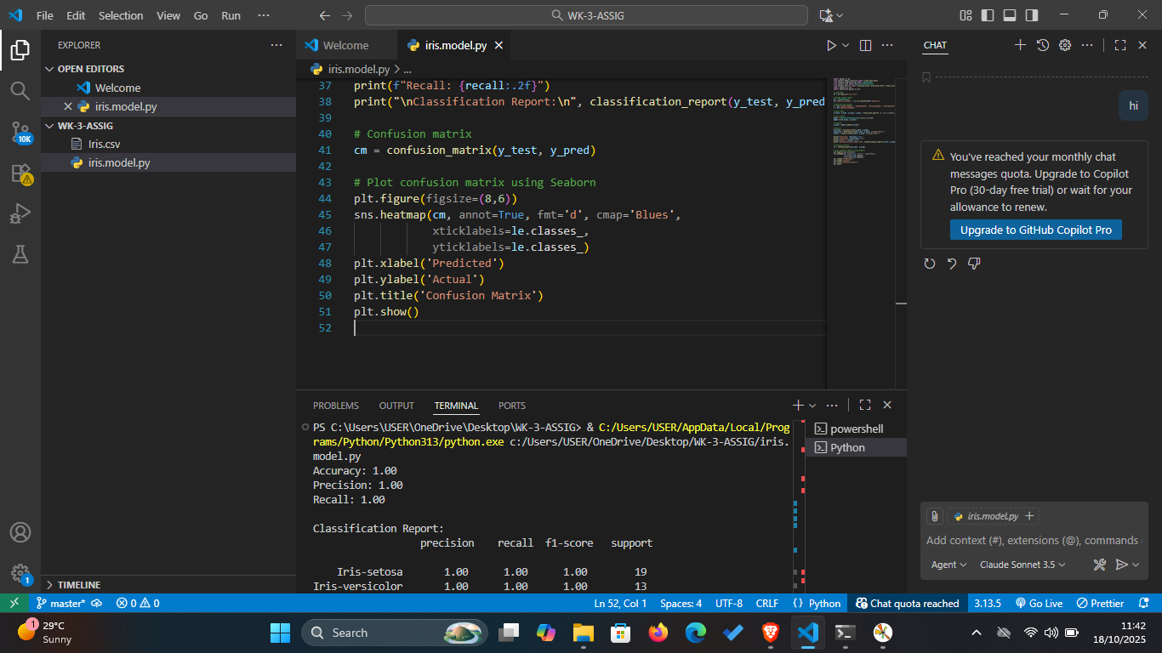 **Confusion matrix for the Iris model."**

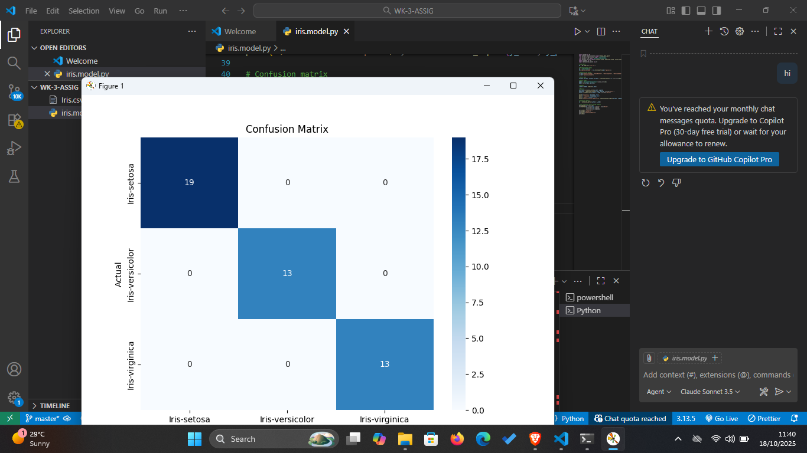

**Screenshots showing accuracy and loss of the CNN-based model.**

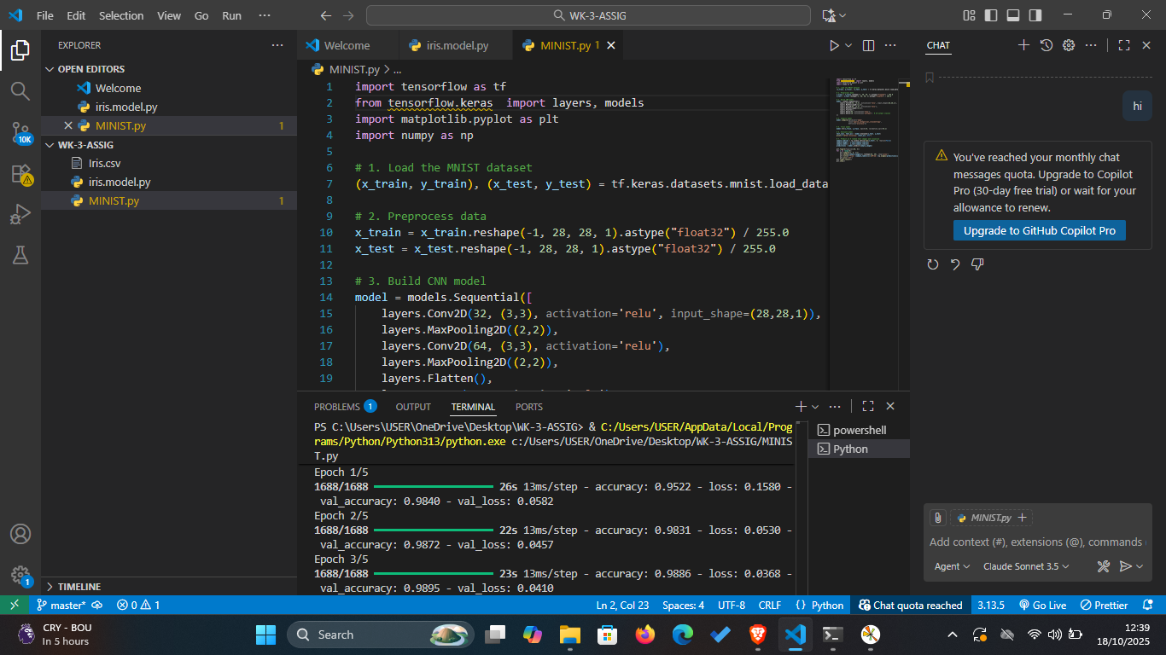

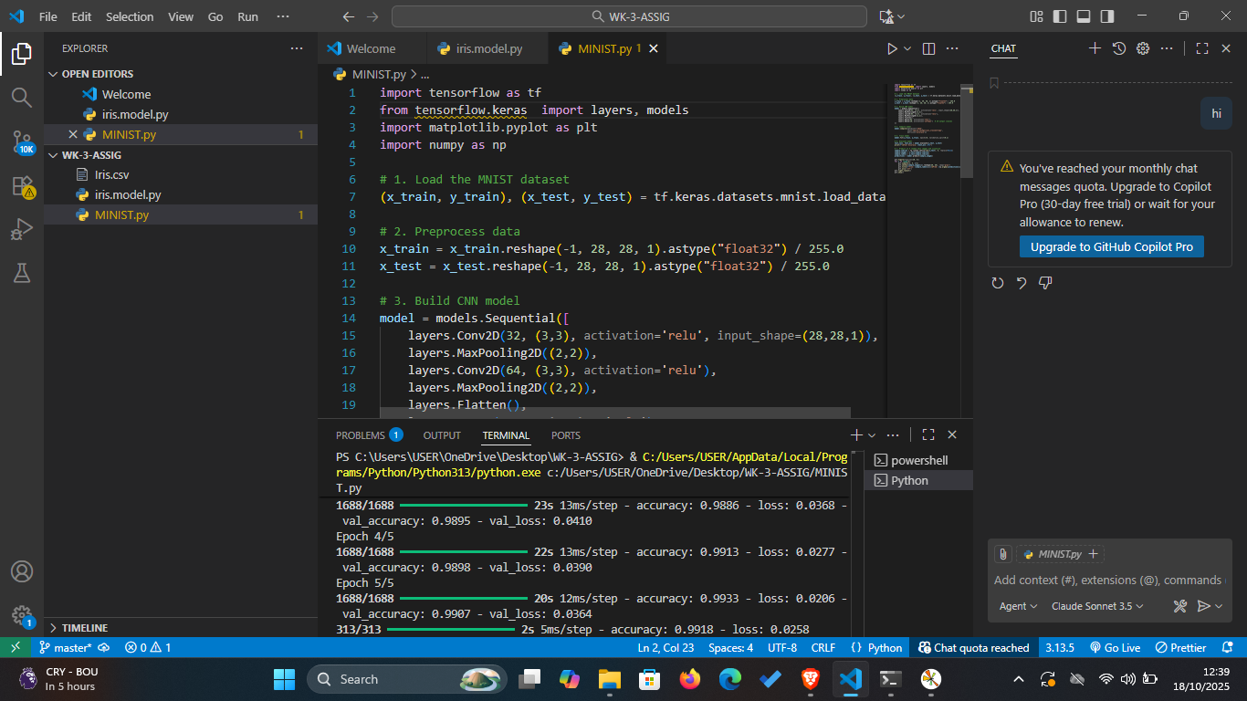

. **Visualization of the model’s predictions on five sample images**

